PROJECT
REPOT FILE

BILL GENERATOR

NAME: SWASTIK GUPTA
RESISTRATION NO.: 25BAC10033

Project Report: Bill Generator
This document provides a detailed outline for a formal project report, covering all 15 required sections based on the "Bill Generator.py" script.

Introduction
This project introduces a Command-Line Interface (CLI) application developed in Python to automate the generation of sales receipts or invoices. The primary goal is to provide a simple, accessible, and error-resistant tool for generating professional-looking documentation. By leveraging the fpdf external library, the application takes itemized sales data as interactive input and produces a structured PDF file. The project demonstrates fundamental programming concepts such as modularity, data structure utilization, and robust error handling.

Problem Statement
Small businesses and individual sellers often rely on manual, error-prone processes (like handwritten notes or basic spreadsheets) for invoicing. This lack of standardization leads to calculation errors and unprofessional documentation. The challenge addressed by this project is the need for a free, simple, and automated digital tool that can convert itemized sales data into a formal, structured, and printable invoice format, improving both efficiency and accuracy.

Functional Requirements
Functional requirements define what the system must do. The Bill Generator project is structured around three core functional modules:
Requirement ID | Module | Description
FR1.0 | Input & Aggregation (basic function) | The system must interactively accept the store name, product name (string), price (float), and quantity (integer) from the user.
FR1.1 | Calculation Logic | The system must calculate the item total (Price × Quantity) and the final Grand Total (c).
FR2.0 | PDF Generation (text_to_pdf function) | The system must take the aggregated item list and totals and format them into a structured bill using the fpdf library.
FR2.1 | File Output | The system must save the final output as a PDF file named Bill.pdf (dto).
FR3.0 | Error Recovery | The system must handle non-numeric input errors (e.g., text for price) gracefully, informing the user and allowing them to re-enter data without losing previous entries.

Non-functional Requirements(NFR)
Non-functional requirements describe how well the system performs.

Requirement | Description
Usability (NFR1) | The CLI must be intuitive, guiding the user through the input process with clear, self-explanatory prompts.
Robustness (NFR2) | The application must maintain operation when faced with typical user typos, specifically recovering from ValueError exceptions during numerical input.
Efficiency (NFR3) | The PDF generation must be near-instantaneous, suitable for real-time sales transactions.
Portability (NFR4) | The application must run on any operating system (Windows, macOS, Linux) that has Python 3 installed.

System Architecture
The project employs a simple Two-Tier/Modular Architecture:
- Presentation/Input Tier: Handled entirely by the console, managed by the basic() function. It provides the interface for data entry and displays the final console summary.
- Application/Processing Tier: Also managed primarily within the basic() function (calculations) and the text_to_pdf() function (data structuring and rendering). This tier handles all the business logic and file output.
The external fpdf library acts as a specialized rendering engine, supporting the Application/Processing Tier.

Design Diagrams
Use Case Diagram
The system involves a single primary actor: the User.
Workflow Diagram
The process is linear and sequential, with a core loop for item input.
Sequence Diagram
This diagram illustrates the flow of control and data between the primary functions.
Class/Component Diagram
The core components are the two functions and the external library.
ER Diagram (if storage used)
Not Applicable. The project does not use a database or persistent storage; all data (li list of dictionaries) is held in memory for the duration of the script's execution.

Design Decisions & Rationale
Decision | Rationale
Use of fpdf | Chosen for its simplicity and reliability in generating professional, fixed-layout documents, making it ideal for a standardized invoice.
Data Structure (List of Dicts) | Using a list (li) to hold dictionaries (item) is the most appropriate Pythonic structure to manage multiple records, where each record has distinct, labeled fields (Product Name, Price, Quantity).
Input Error Handling (The Fix) | Critical Rationale: The original code used break inside the except ValueError block. This was replaced with continue. The rationale is that a user typo should not terminate the session; continue ensures the application is robust, allowing the user to retry input without losing accumulated data.
Custom Page Size | Used custom=(130, 400) to simulate a narrow, potentially long thermal receipt format.

9. Implementation Details
The implementation centers on the segregation of duties between the two main functions:
- basic(dto, title):
  - Data Structure: li = [] (list of dictionaries) and c = 0 (accumulator for total cost).
  - Loop Control: Uses while True with explicit checks for 'Y' (continue) and 'R' (break to exit cleanly).
  - Calculation: item['Total Price'] = pri * q.
- text_to_pdf(li, title, tcost, dto):
  - PDF Setup: pdf=FPDF(unit='mm', format=custom) initializes the document.
  - Layout: Uses pdf.cell() with hardcoded widths (40, 20, 30) to create the bill's column layout and pdf.ln() to move to the next line.
  - Output: pdf.output(dto) saves the file.

Screenshots / Results
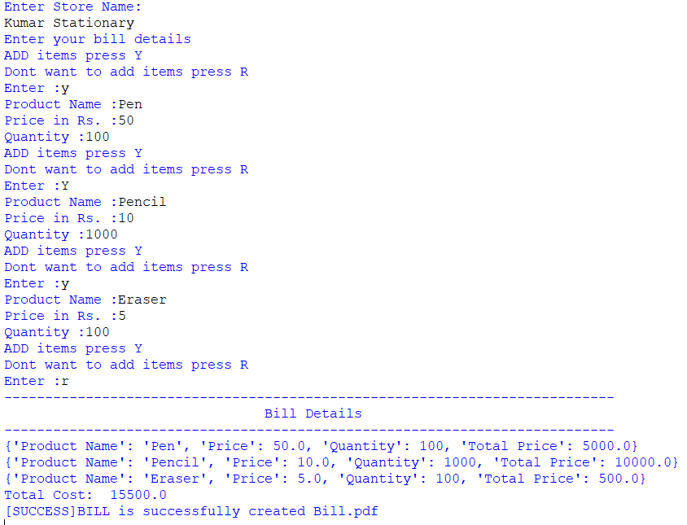
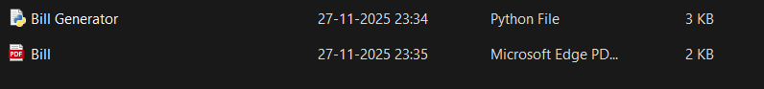
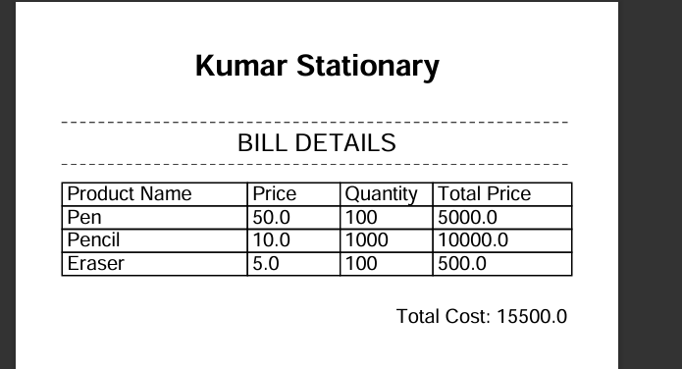
Testing Approach
The project followed a two-pronged testing approach:
- Unit Testing (Functionality):
  - Calculation Test: Manually verified that pri * q and the final c accumulator were mathematically correct for various inputs.
  - PDF Structure Test: Verified that the cell widths and data alignment within text_to_pdf resulted in a clean, legible bill layout.
- Integration and System Testing:
  - Happy Path Test (Success): Confirmed the end-to-end flow works when all input is valid (Scenario A in the instructions).
  - Error Recovery Test (Robustness): Crucial Test. Confirmed that the fix (using continue in the except ValueError block) successfully allowed the user to recover from entering text instead of a number for price/quantity without losing prior data or crashing the program.

Challenges Faced
The project faced challenges primarily related to input robustness and precise file output formatting:
- Critical Flow Control Error :
  - The Issue: The most significant design challenge was the initial use of the break statement in the except ValueError block. A simple user typo (entering text for a numeric field) caused the entire item input session to terminate, preventing the PDF from being generated and leading to a functional failure.
  - Resolution: This required a critical fix: replacing break with continue to ensure the application recovers gracefully, prompts the user again, and preserves data integrity.
- PDF Layout and Alignment with fpdf:
  - The Issue: The fpdf library requires all cell widths and positioning to be defined precisely in millimeters. Achieving accurate and visually appealing column alignment for the bill table (Product Name, Price, Quantity, Total Price) proved difficult due to the need for hardcoded dimensions (40, 20, 20, 30). Even minor adjustments required recalibrating the entire layout to prevent text overflow or gaps on the narrow custom page size (130mm).
  - Resolution: Extensive trial-and-error testing was required using pdf.cell() properties to fine-tune the layout and ensure all content fit correctly.
- Data Type Coercion and Enforcement:
  - The Issue: Console input is inherently string-based. Safely converting user input to the required data types (float for price, int for quantity) within a single try block was challenging. Any single failure (e.g., text in price field) would trigger the ValueError and halt the input attempt.
  - Resolution: The necessity to strictly enforce these types complicated the structure of the input loop, underscoring the limitations of handling multiple data coercions interactively.

Learnings & Key Takeaways
- Importance of Robust Error Handling: Learned that catching errors is only the first step; the more crucial step is determining the appropriate recovery mechanism (continue vs. break vs. pass).
- External Library Integration: Gained practical experience integrating and utilizing an external library (fpdf) to extend Python's core capabilities beyond the console.
- Modular Design: Reinforced the benefits of separating I/O and business logic into distinct functions, making the code easier to debug and maintain.

Future Enhancements
Future iterations of the Bill Generator could include:
- Tax/Discount Calculation: Add input fields and logic to automatically calculate Sales Tax (e.g., GST or VAT) and apply percentage-based discounts.
- Data Persistence: Integrate a simple storage mechanism (e.g., saving bills to a CSV file or using an SQLite database) to log past transactions.
- GUI Interface: Migrate the user interface from the CLI to a Graphical User Interface (GUI) using libraries like Tkinter or PyQt for improved usability.
- Currency Formatting: Implement explicit currency formatting (e.g., Rs. 1,500.50) for cleaner output.

References
- Python Documentation: Official documentation for language syntax and built-in functions.
- fpdf Documentation: Official documentation for the FPDF Python library: http://www.pyfpdf.org/

